MS SQL SERVER
Standard Operating Procedures
(SOP)

User management in SQL Server 2014

Submitted to



By



CIS, Wipro Limited

Document Details

Project Name | Innogy SE
Account | CIS
IT Component/Application Title | User management in SQL Server 2014
Current Version | 1.6
List of Contributors | Pradipkumar Kansara, Kiran Bhalekar, Ayushi Gautam, Sivakumar Goud, Ayushi Srivastava
Customer Contact Information

Version History
(All revisions made to this document must be listed in chronological order. All revisions must be approved. Review and Approval can be done by an internal source or by the customer)
Version | Date of Revision | Description | Author | Reviewed By | Approved By
1.0 | 29-08-2015 | Initial Draft | Ayushi Gautam | Pradipkumar Kansara | Mahesh Keshatwar
1.1 | 04-09-2015 | Document Completed | Kiran Bhalekar | Pradipkumar Kansara | Mahesh Keshatwar
1.2 | 21-08-2016 | Updated document to standard format | Kiran Bhalekar | Pradipkumar Kansara | Mahesh Keshatwar
1.3 | 17-05-2017 | Wipro and Innogy Logo changed | Kiran Bhalekar | Pradipkumar Kansara | Mahesh Keshatwar
1.4 | 18-08-2017 | Updated document to Wipro Standard format with header and footer | Kiran Bhalekar | Pradipkumar Kansara | Mahesh Keshatwar
1.5 | 29-11-2017 | Updated the document for SQL server 2014 | Ayushi Gautam | Pradipkumar Kansara | Santosh Badiger
1.6 | 19-12-2018 | Updated the content | Ayushi Srivastava | Pradipkumar Kansara | Santosh Badiger

TABLE OF CONTENT

- Purpose………………………………………………………………..
- Scope……………………………………………………………………
- Process Flow For Granting Privileges………………….
- User Login Management……………………………………..
  - User Login Management In SQL Server 2014.
- Note……………………………………………………………………..
- Reference……………………………………………………………..

Purpose
This document is prepared for the management and troubleshooting of SQL Server Database Administration Services at Innogy.

Scope
This document is prepared for Wipro SQL team and provides the concepts, management and troubleshooting aspects of User Management for the administration of the SQL Server database.

Process Flow for Granting Privileges
The process flow for granting privileges is as below:


Note: The above flow is a draft. It should be modified as per the customer needs.

User Login Management
Login is server principals that can connect to a particular server. Login use either Windows Authentication or SQL Server Authentication to identify themselves to the server. Windows Authentication uses the credentials of the Microsoft Windows® account. SQL Server Authentication uses a user name and password provided by SQL Server outside the Windows security infrastructure. Windows Authentication is more secure because it relies on Windows to maintain security information rather than on the SQL Server local security database

User Login management in SQL Server 2014

Opening the SSMS
Go to start >Run > Type SSMS > Enter

The SQL Server Management screen displayed as follows:
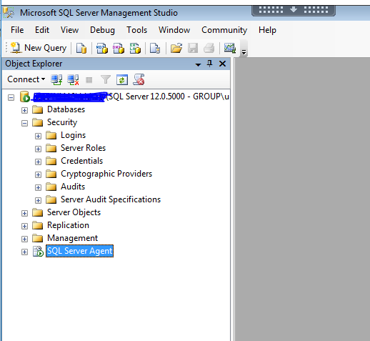

New User Login Creation:
Now expand Security > Logins > Right click Logins > New Login

Right click on Login. The following screen is displayed below:

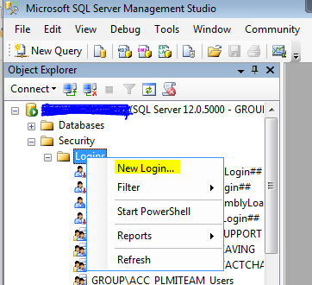
Click on “New Login…”

There are two modes of Authentication:

- Windows Authentication
- SQL Server Authentication

First, we will go Through Windows Authentication:
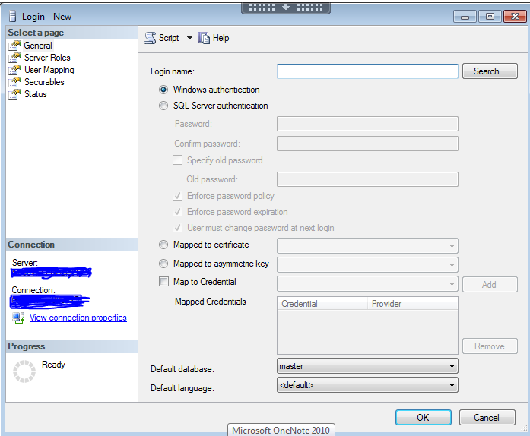
In the SQL Server Login Properties – New Login window do the following:

- Name: specify Login name\UI ID of the user.
- Select Windows Authentication and search, confirm the Id exists in domain by “check names”
- Make sure to change the default database to the user database and not to burden Master database.
- Click OK.

The search window will be displayed as follows:

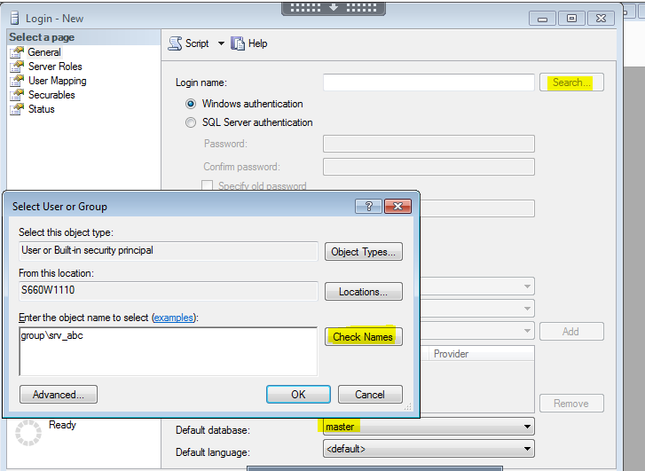

Now Once the Login is created, Go to User Mapping from the left pannel.

Assigning permissions to the User Login:

Opening the SQL Server Login Properties – new login Window:
Right click on the existing user login name and go to Properties.

Assigning Server Roles to the User Login:
In the SQL Server Login Properties – new login Window go to Server Roles tab.

Generally, we do not provide any server roles to users until any development work is going on and the user needs server roles temporarily.

In the below screenshot, all server roles are displayed, public is provided by default. According to optimum use, we provide these roles to users.

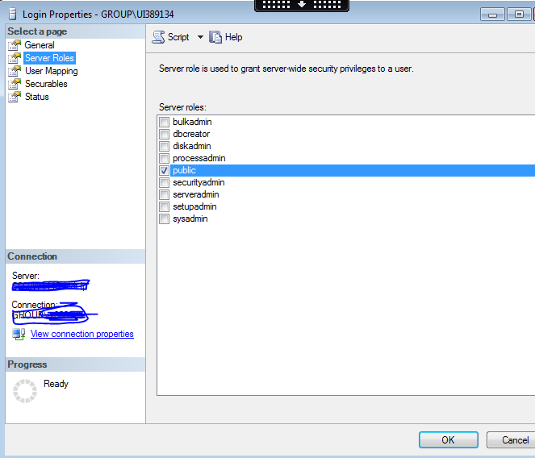

Below are the server roles and their explaination :

Note: Do not provide sysadmin to any user, if such requests come, it has to go through proper business justification, and all manager approvals, also it has to be a temporary access.

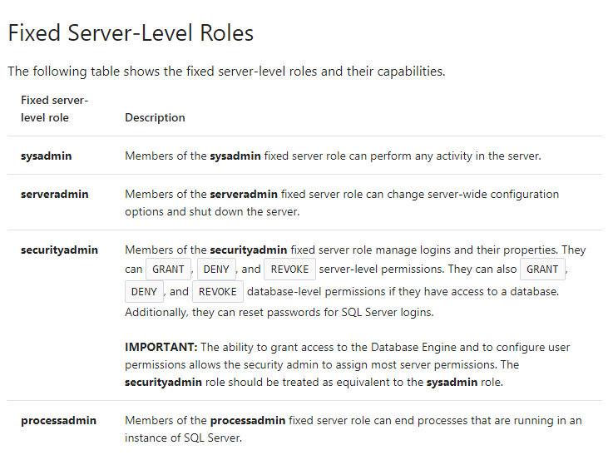
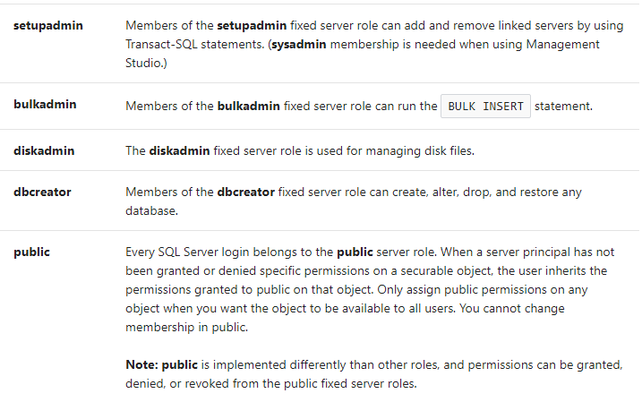

Assigning Database Roles to the User Login:

The below screenshot shows how to assign database roles:
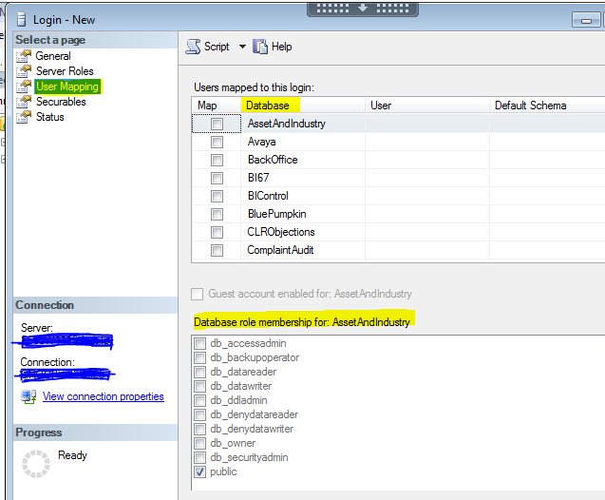
Select the required database Roles that are to be assigned to the user login.
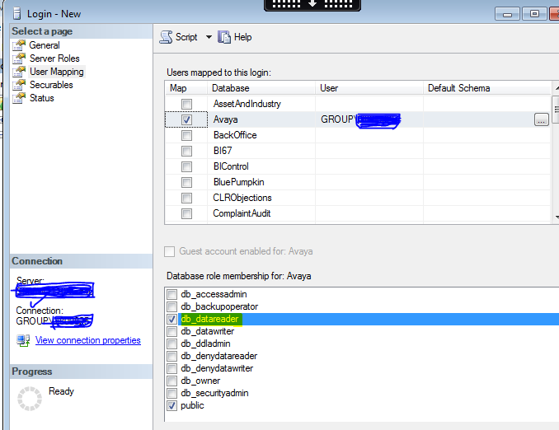

Below are the database roles and their explaination :

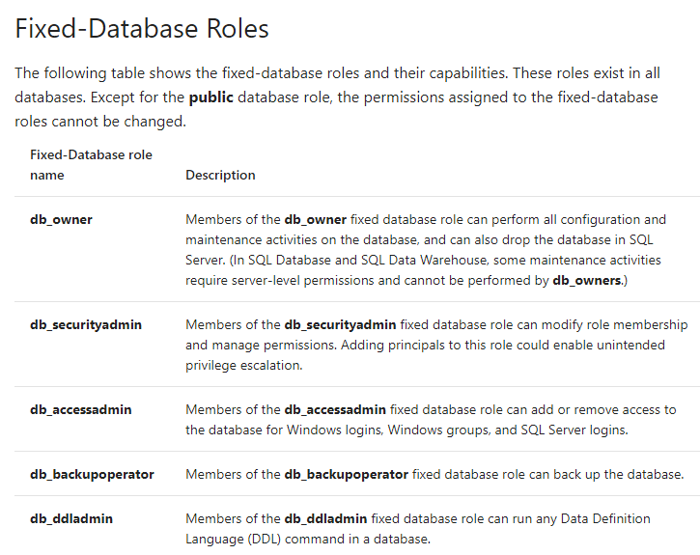

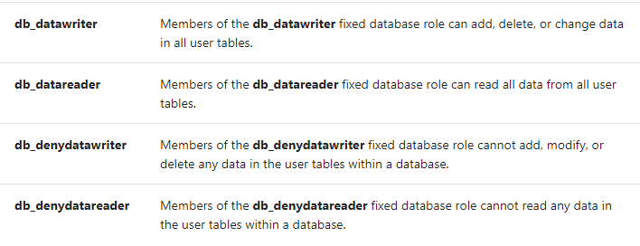

In the SQL Server Login Properties – New Login window do the following:

- Name: specify Login name of the user.
- Select SQL Server Authentication and specify the password.
- Uncheck Enforce Password related all the three fields so that the password never expires.
- Make sure to change the default database to the user database and not to burden Master database.
- Store the password in our shared folder protected “assorted password” sheet.
- Click OK.
- In the Confirm Password window, reenter the password and click OK.
- The New User Login is created.

The confirm password window will be displayed as follows:

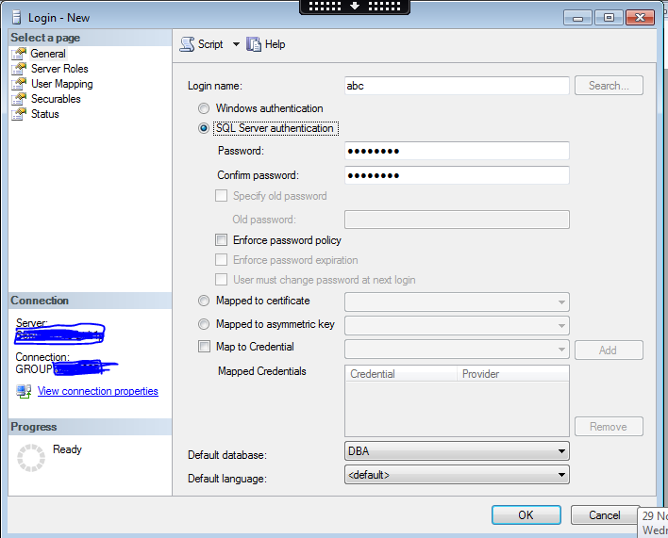

Assigning Roles for SQL server Authentication would be same as Windows Authentication.

Revoking permissions from User Login:

Open the SQL Server Login Properties new login Window:
Open the SQL Server Login Properties new login Window as described in the step 3.2.1

Revoking Server Roles from User Login:
Deselect the Server Roles that are to be revoked from user login.
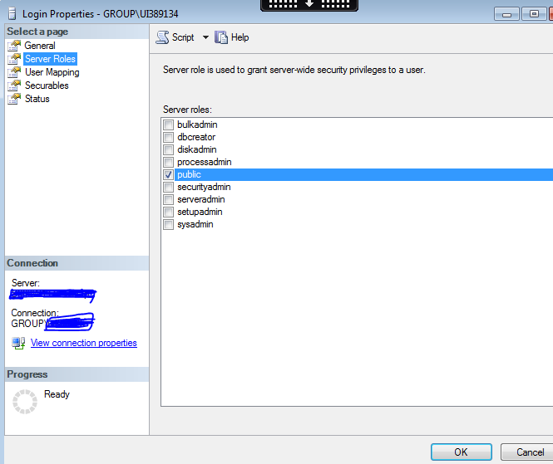
Uncheck the server role, which has to be revoked.

Revoking Database Roles from User Login:
Select the database for which the permission has to be revoked.
Deselect the database role that is to be revoked.

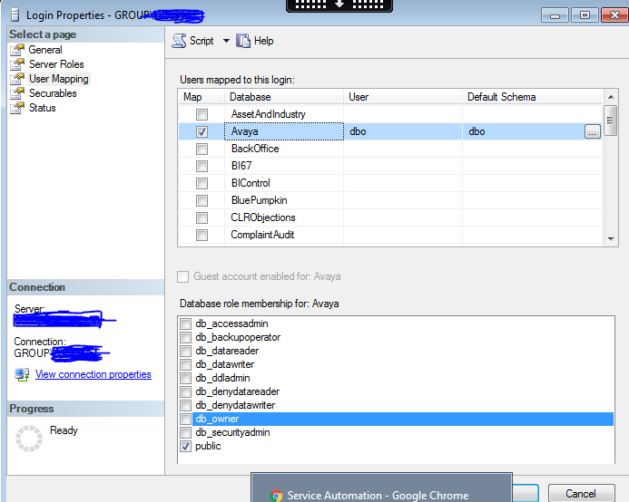

Click OK to revoke the Server Roles and Database roles.

Delete user login
Right click on the existing user login. Click on Delete.

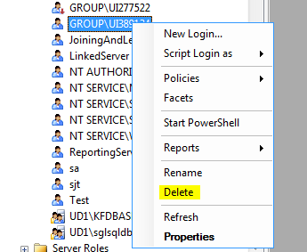

Select “ok” to delete the user login. Else select “cancel”.

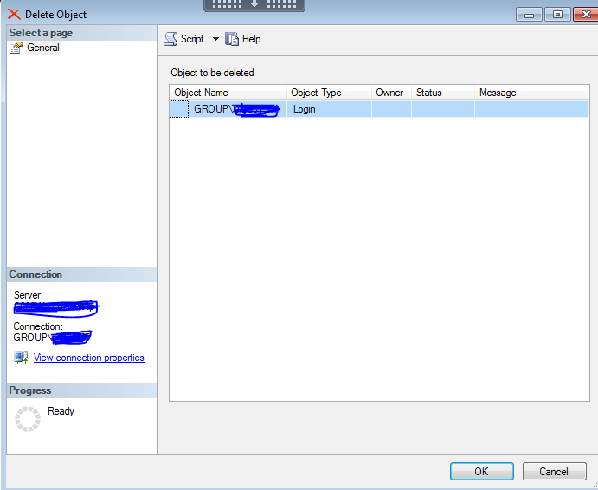

Note

Here the I.P.s used are on an example basis. So, change the I.P.s wherever necessary.

Reference
- http://www.microsoft.com/technet/prodtechnol/sql/2005/mgsqlexpwssmse.mspx
- http://msdn2.microsoft.com/en-us/library/ms189121.aspx
- http://msdn2.microsoft.com/en-us/library/ms188659.aspx

